Arduino Alarm Clock Report

Table of Contents

How To Use The Alarm Clock 2

Set & Use Alarm 2

Detailed Instructions 2

System Implementation Description 4

Flowcharts & Diagrams 5

Tests & Test Results Analysis 6

# How To Use The Alarm Clock

## Set & Use Alarm

1. Power on Arduino. This should take you to a display mode containing the current time.
2. Press SELECT to change to the update time mode.
3. Press SELECT again to change to the alarm mode.
4. Use the UP/DOWN arrows to adjust the time currently under the cursor. To move the cursor left or right, press LEFT/RIGHT buttons.
5. To move the cursor to minutes, press the Right button.
6. Press UP/DOWN buttons to change minutes.
7. Press RIGHT again to move the cursor to the ON/OFF indicator. Press UP or DOWN to toggle the alarm on or off. The screen will go green to indicate its on, or red to indicate its off as well as the text on screen.
8. Press SELECT to move back to the current time display mode, and wait for the alarm to go off.

Note: All button functions are displayed on the screen scrolling along the bottom of the screen.

## Detailed Instructions

When the Arduino is first turned on, it will display the current time with a blue background. Throughout the use of the alarm clock, button prompts will be displayed on the bottom on the screen using some scrolling text to show what buttons can be pressed and what functions they do. There are a total of 3 display modes you can navigate through, *Current Time, Set Time* and *Set Alarm Time*.

In the *Current Time* display mode, the only button that can be pressed is the SELECT button. In all display modes, SELECT will move to another mode in the Arduino. From the *Current Time* display mode, pressing select will move you to the *Set Time* display mode.

The *Set Time* display mode allows you to set the current time the alarm clock uses. Use the Up/Down buttons to add time or takeaway time respectively. Whether you are adjusting Hours/Minutes/Seconds is shown by a blinking cursor on top of the part of the time you are changing. To move this cursor, use the Left/Right buttons. Pressing the SELECT button on the screen will move you to the *Set Alarm Time* display mode.

The *Set Alarm Time* allows you to set the time the alarm will go off, in a 24hr clock format. Use the Up/Down buttons to add 1 hour or 1 minute depending on where the cursor is. The cursor can be moved left/right with the left/right buttons. If the cursor is on the “ON” or “OFF” indicator, pressing the Up or Down buttons will toggle whether the alarm is active or inactive.

When the alarm is switched on (indicated by a green background on the *Current Time* mode or a green background and “ON” indicator in the *Set Alarm Time* display mode, the device checks the current time against the alarm time. If the current time arrives at the alarm time (At 0 seconds past the minute) the device will enter *Alarm Mode*. In this mode, the screen will flash multiple different colours, and will display button prompts to stop the alarm, or snooze it.

If the stop alarm button is pressed (SELECT), the alarm will be turned off and you will be returned to the *Current Time* display mode. If the snooze button is pressed (UP), you will be taken to *Snooze Mode* for 30 seconds. In these 30 seconds, you can cancel the snooze by turning the alarm off with the SELECT button. If you don’t do this, after 30 seconds the alarm will go off again and enter *Alarm Mode*. The same options are presented to you, to either snooze again or turn the alarm off.

After the alarm is disabled, the alarm indicator will indicate off in *Alarm Mode*. To have the alarm go off again the next day, you must switch it back on.

It is important to note that the alarm will only go off when the device is either in *Snooze* or *Current Time* display modes. If it is not in these modes, the alarm time won’t be checked to ensure weird behaviour does not occur if you are changing the current time or alarm time in their respective display modes.

# System Implementation Description

When the Arduino is first powered on, the system entered into 1 of its three *displayModes, currentTime*. The *displayModes* variable is an enum with the states *currentTime, alarmTime,* and *updateTime.*

In the *currentTime* display mode, the Arduino simply displays the current time stored the Time library. It does everything to do with this display mode in the function *printCurrentTime()*. This function will set the backlight colour to either blue or green depending is the alarm is off or on respectively. It will also read the values from the Time libraries functions *hour(), minute(),* and  *second()* and pad them with 0’s if required to get the values to be 2 digits long. On the bottom of the screen it prints a string which says what the SELECT button does (change to the next display mode) because this is the only button that is listened whilst in this *displayMode.*

In the *updateTime* display mode, there is a cursor displayed on the screen. The cursor works by replacing certain parts of the time display string with a custom character which is just a solid block, every 5 loops out of 20. The cursor moves between 3 states defined in an enum, which you switch by pressing the LEFT or RIGHT buttons.

The *alarmTime* display mode works much the same way as the *updateTime* mode, but instead of displaying seconds it displays an indicator for if the alarm is on or off. The backlight colour in the mode also matches the alarm state to indicate if it’s on or off (green for on, red for off).

When in the *currentTime* display mode, the program will check if the current time equals the alarm time. If it does, then the program will enter an *alarmSounding* mode. This mode is not a part of the *displayModes* enum, but is just a boolean variable. This means that the only time *alarmSounding* mode is entered is when the device is in *currentTime* mode, this is to prevent the alarm going off unexpectedly whilst changing the time or changing the alarm time.

When in the *alarmSounding* mode, you can press SELECT to turn the alarm off and go back to the *currentTime* display mode. You can also press the UP button to enter display mode, which turns the snooze bool variable to true, and adds 30 seconds to the current time and sets that time to the alarm time. In snooze mode, you can still disable the alarm with the SELECT button. After 30 seconds, the alarm will go off again and snooze mode will be turned off, allowing you to enter snooze again or disable the alarm.

# Flowcharts & Diagrams

This is a state diagram describing how the user changes through different states/display modes of the alarm clock.

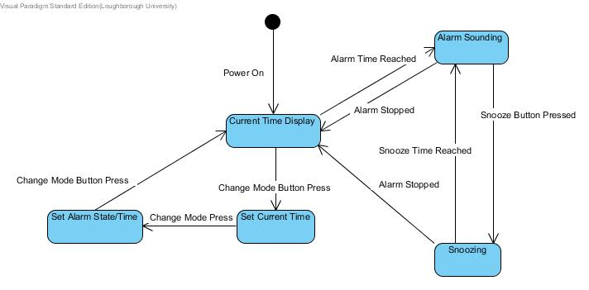

# Tests & Test Results Analysis

|  |  |  |
| --- | --- | --- |
| Functionality | How it should work | Does it work? |
| Change mode into update time | Update time screen is displayed | Yes |
| Change mode into alarm set mode | Current alarm time is displayed, with alarm indicator saying if its on or off. | Yes |
| Change mode back into current time mode | Current time is displayed on screen | Yes |
| Move cursor in update time mode left/right | Cursor flashes on top of the part of the time it would adjust if you press the up/down buttons. | Yes |
| Move cursor in alarm time mode left/right | Cursor flashes on top of the part of the time it would adjust if you press the up/down buttons. Cursor also flashes on top of alarm indicator instead of seconds | Yes |
| Adjust time element under the cursor when Up/down buttons are pressed | The element of time (hour, minute, second) has 1 unit added when the up button is pressed, and 1 unit is taken away when the down button is pressed. | Yes |
| Alarm state toggles on or off when the cursor is over the alarm indicator on the alarm set display mode when up/down buttons are pressed | Alarm states toggles on or off when up/down button is pressed | Yes |
| Time elements loop around when the maximum unit is reached | Hour 23 turns into 00 when up is pressed, 00 turns into 23 when down is pressed, minute and second 59 turns into 00 when up is pressed, minute and second 00 turns to 59 when down is pressed | Yes |
| Device flashes multiple colours very quickly when the alarm time is reached. | When the alarm in switched on and the device is in the current time display mode | Yes |
| Snooze function | When UP is pressed whilst the alarm is going off, the alarm should enter Snooze mode | Yes |
| Alarm disable | When alarm is sounding, pressing SELECT returns you to the current time display mode and turns the alarm off | Yes |

All tests were thankfully successful, and no changes were necessary.